W4 Challenge

**Activity Directions**

Estimated time: 40 minutes

From the images below create one webpage to look just like them. Note: There are two images because the title "Education" has a hover effect of turning black when the user hovers over the title. You are welcome to work in groups.

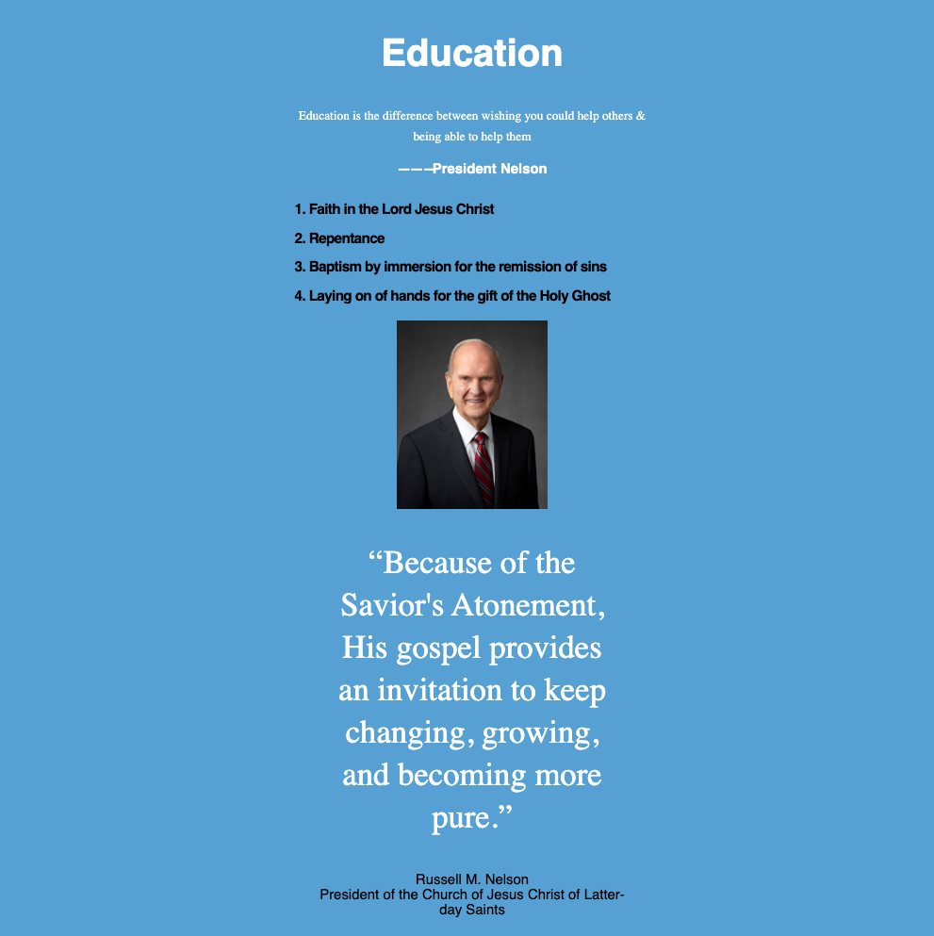

W04 image without hover

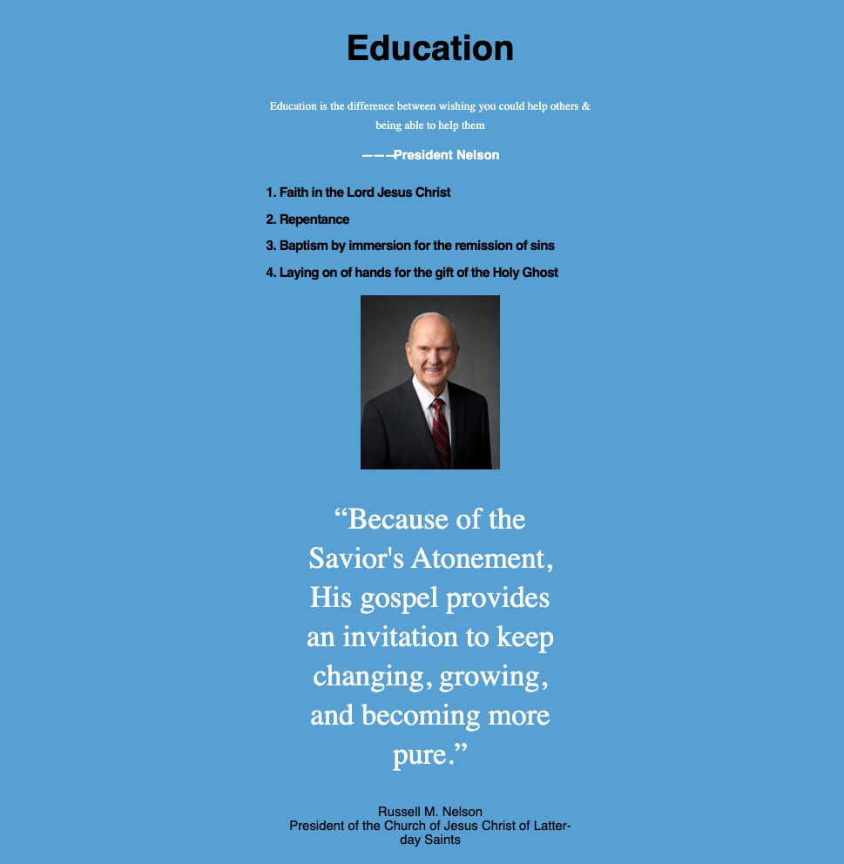

W04 image with hover